Selby United Church
December 18th, 2022
Pageant Sunday

Welcome

OPENING HYMN: VU# 36 - ANGELS FROM THE REALMS OF GLORY

Advent Candle Lighting and Opening Prayer

HYMN: VU#6 - A CANDLE IS BURNING (VERSE 4)

Special Music: “Away in A Manger”

Scripture Reading: Matthew 1:18-23

Monologue: “Coming Home for Christmas: God in the Mess”

Sunday School Pageant – Scene 1

HYMN: O LITTLE TOWN OF BETHLEHEM

Sunday School Pageant – Scene 2

HYMN: MARY DID YOU KNOW?

Sunday School Pageant – Scene 3

HYMN: THE FIRST NOEL

Sunday School Pageant – Scene 4

HYMN: HARK THE HERALD ANGELS SING

Sunday School Pageant – Scene 5

HYMN: WE THREE KINGS

Sunday School Pageant – Scene 6

HYMN: BEAUTIFUL STAR OF BETHELEHEM

Sunday School Pageant – Conclusion

SONG: WHAT A GLORIOUS NIGHT

Prayer of the People and The Lord’s Prayer

Dedication of the Offering

HYMN: VU#62 – ONCE IN ROYAL DAVID’S CITY

Benediction

Today’s Worship Leaders:
Minister: Rev. Mike Putnam
Advent Candle Lighters: The Dickerson’s
Special Music: Wyatt Gibbons, Max Putnam and Emmett Wionzek
Scripture Reader: Charley Sexsmith

Announcements
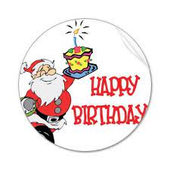
Birthdays
Happy Birthday to all those who are celebrating birthdays in the coming weeks:
Paige Keirstead – December 21st
Emma Perry – December 31st
Tim Hart – December 31st

Christmas Eve Services
Join us on Christmas Eve at 4:30 pm for a family friendly service or 7:00 pm for our candlelight service. Please note there will be no in person service on December 25th or January 01st. Online services will be available on both of these dates.

Christmas Candlelight Concert
Trinity United Church is hosting a Christmas Candlelight Concert on Sunday, December 18th at 4:00 pm. There will be a free will offering for Trinity Music Ministry and Morning Star Mission.

Coffee Time and Breakfast Club
As we begin our new year, we are needing volunteers to sign up for both coffee time and the breakfast club. Sign up sheets are available downstairs. If you have any questions, please see David and Kathy Putnam or Jane Hughes. Your help is greatly appreciated.

Christmas Wish
The gift of love. The gift of peace. The gift of happiness. May all these be yours at Christmas.

Selby United Church

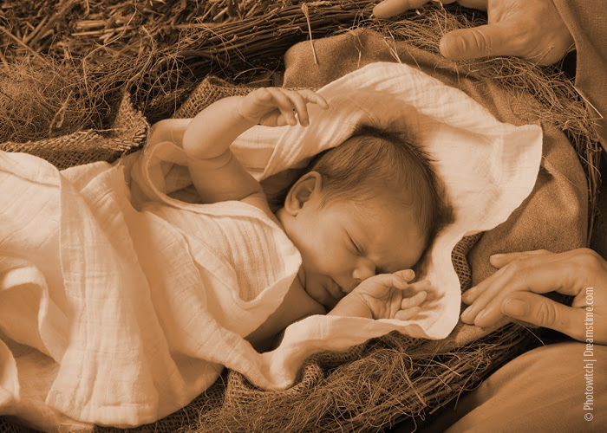

December 18, 2022

